NetWS1: Site1_WesternSahara1

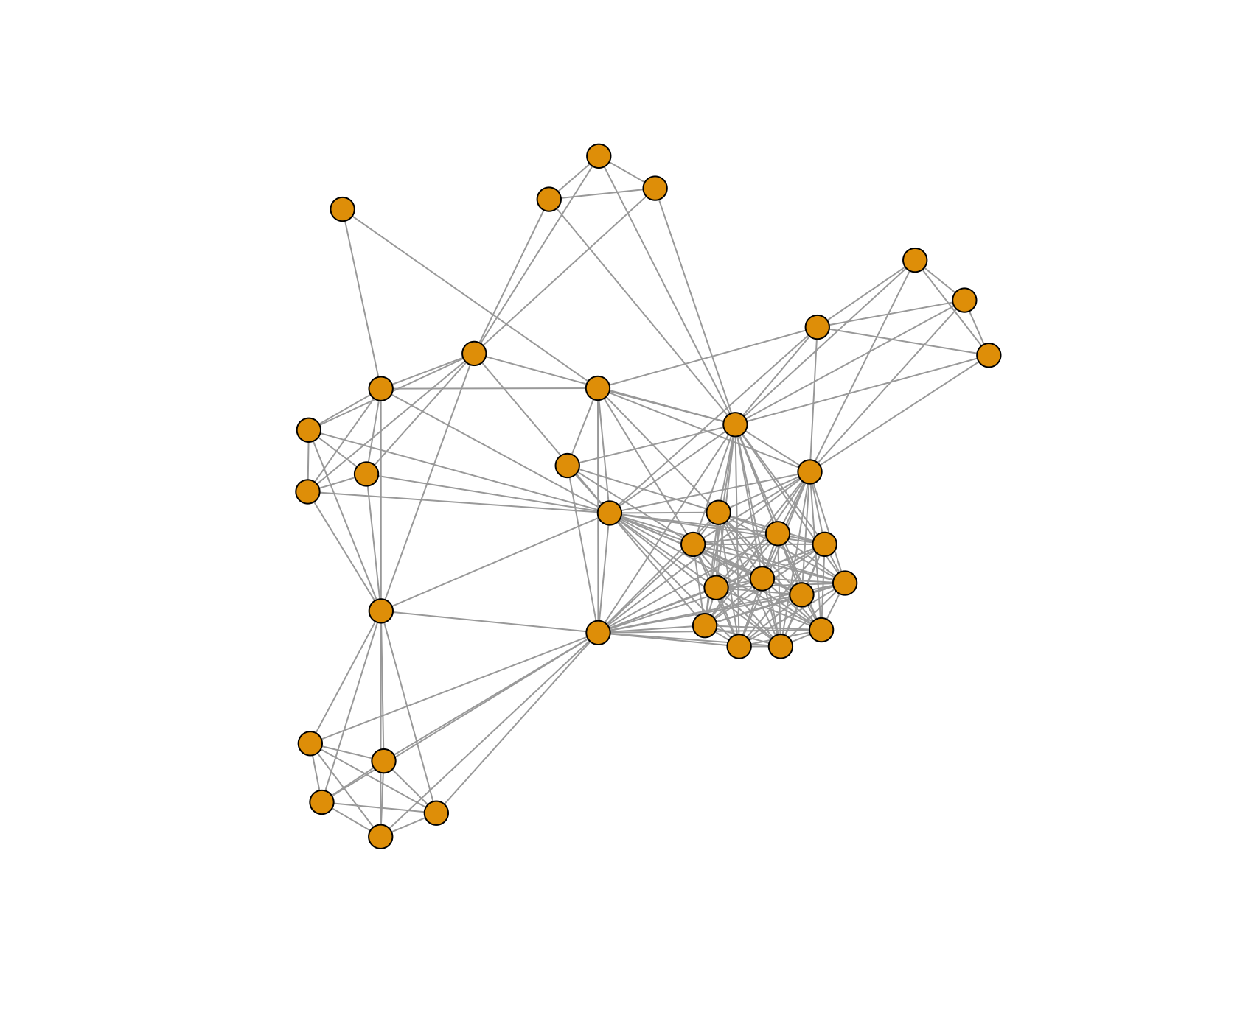

NetWS2: Site2_WesternSahara2

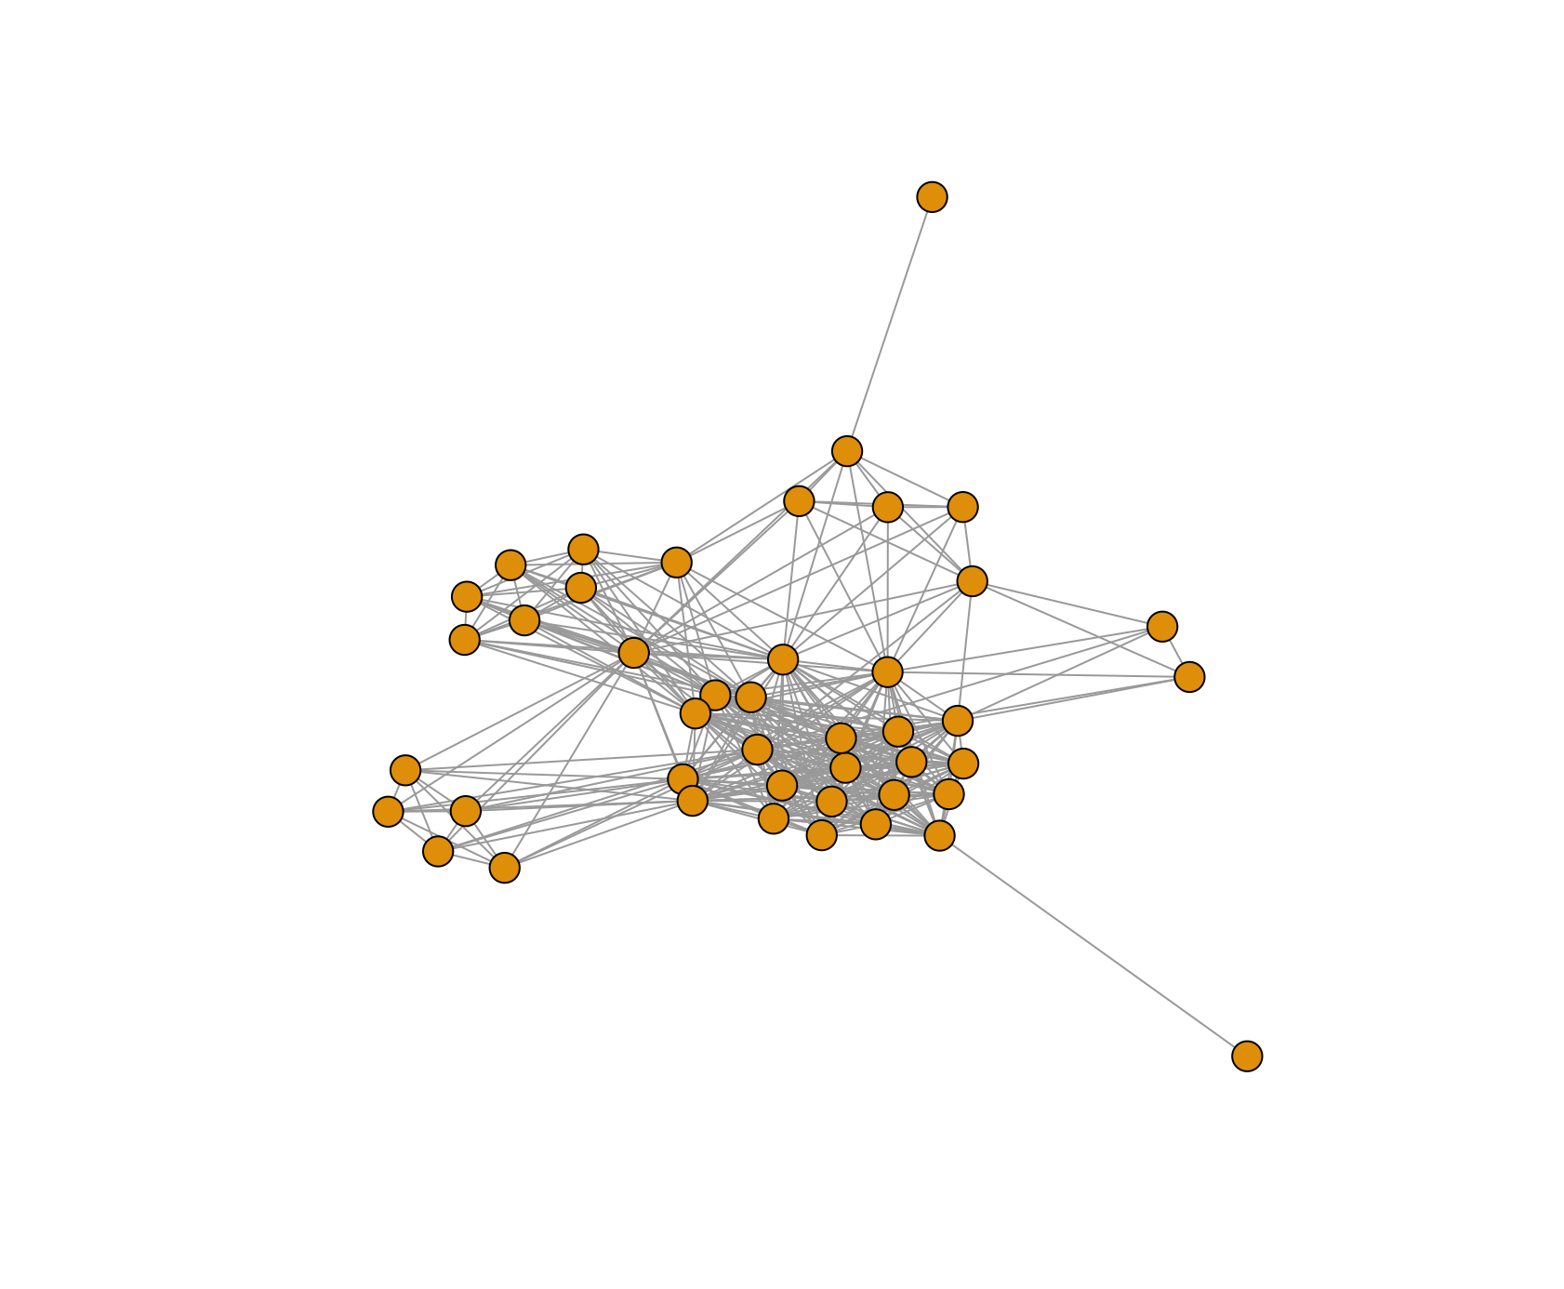

NetWS3: Site3_Fuerteventura1

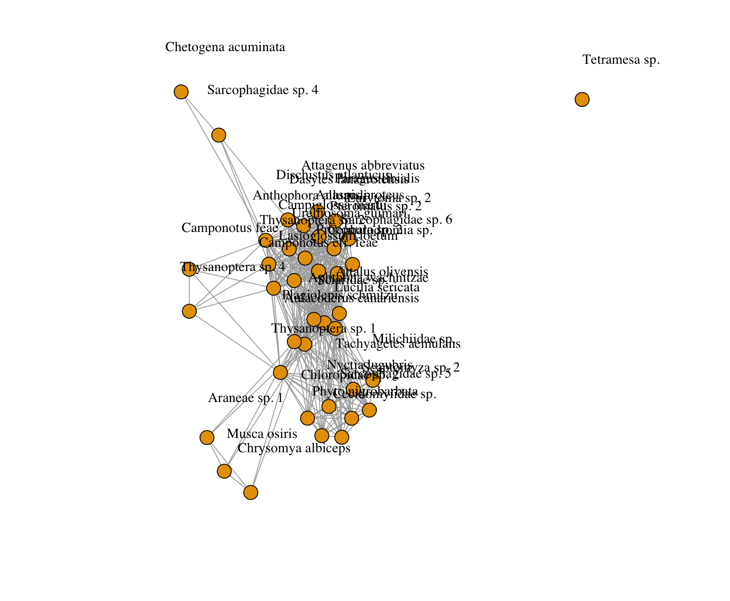

NetWS4: Site4_Fuerteventura2

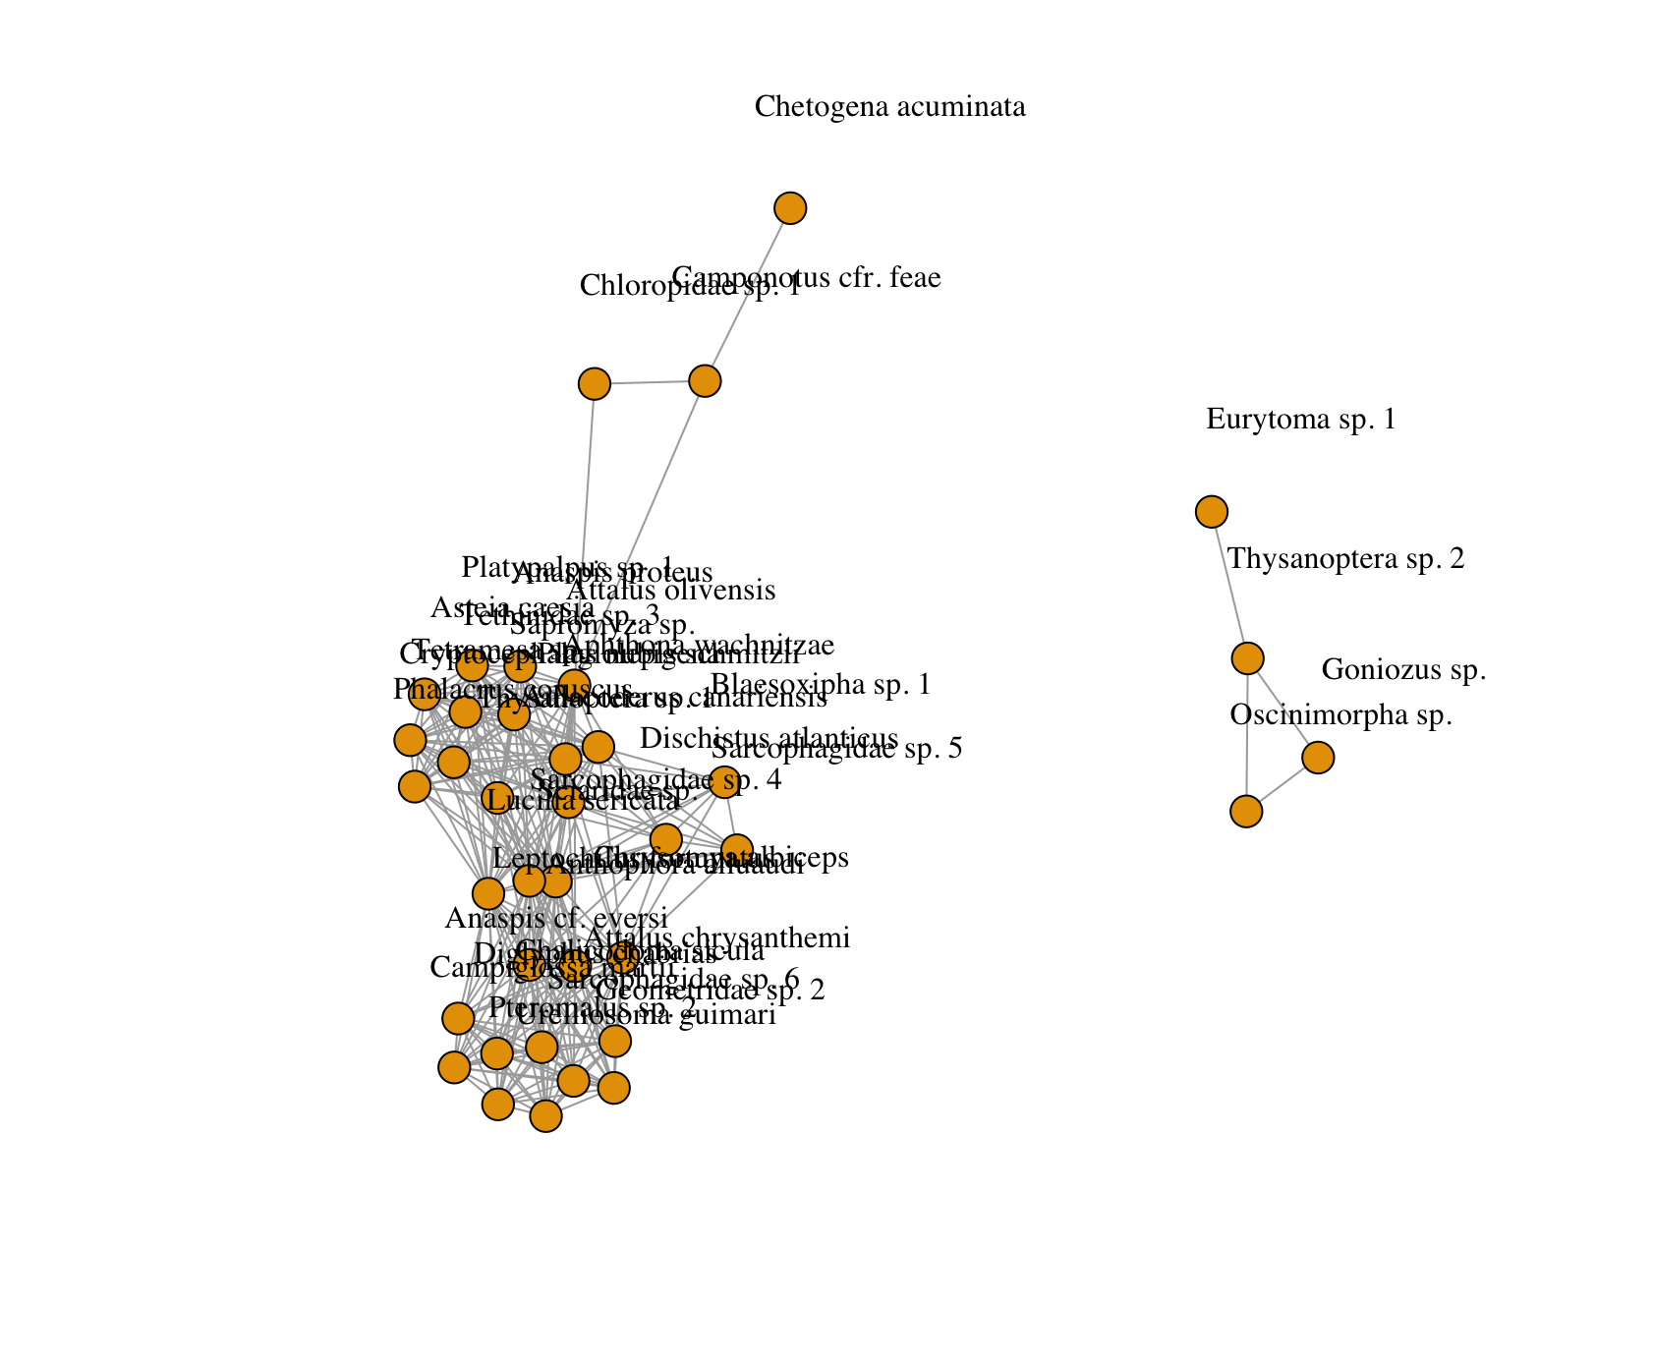

NetWS5: Site5_GranCanaria1

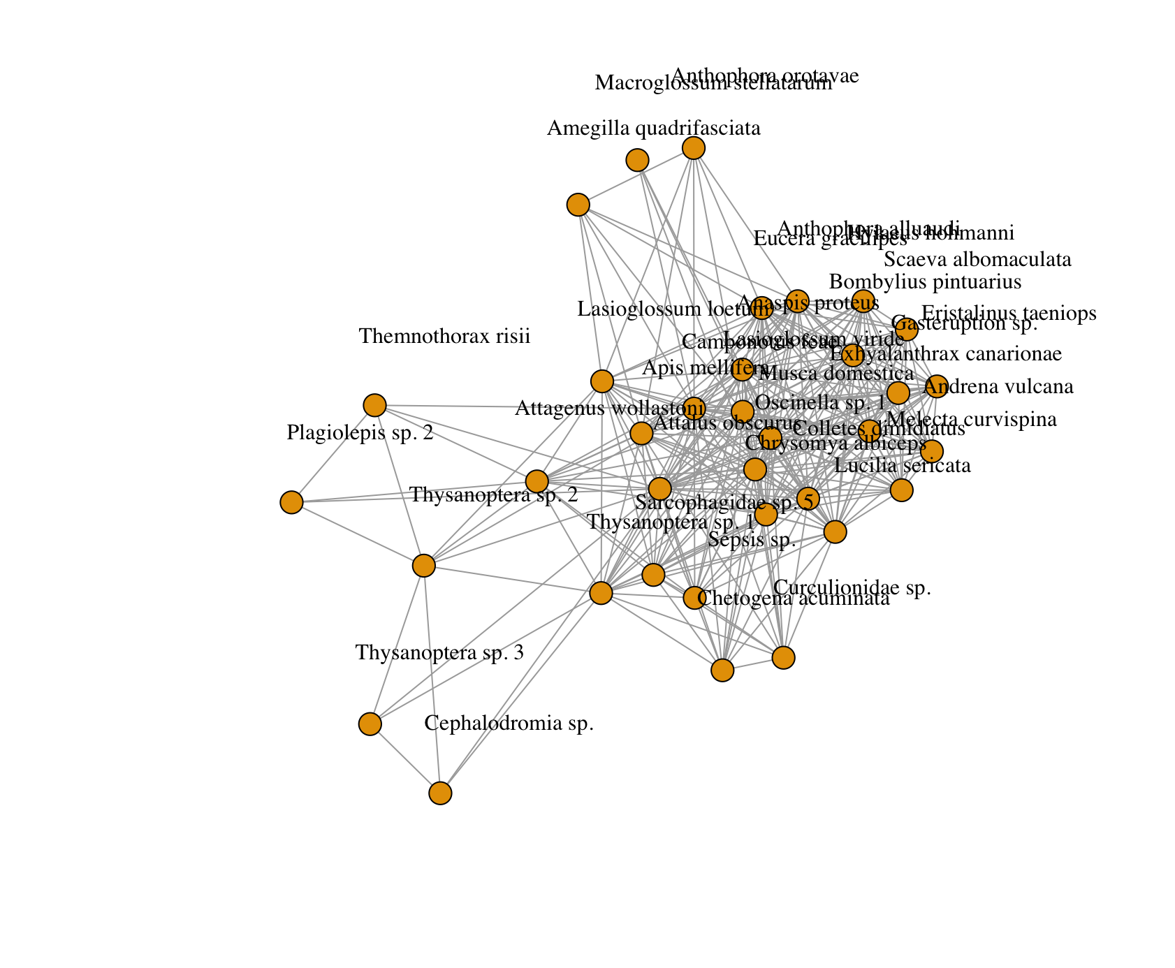

NetWS6: Site6_GranCanaria2

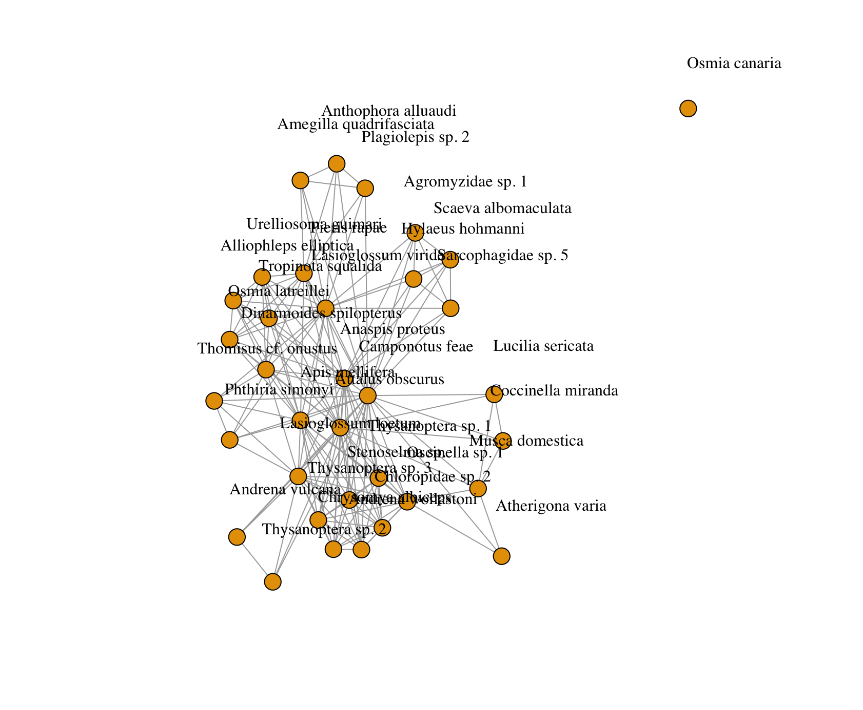

NetWS7: Site7_TenerifeSouth1

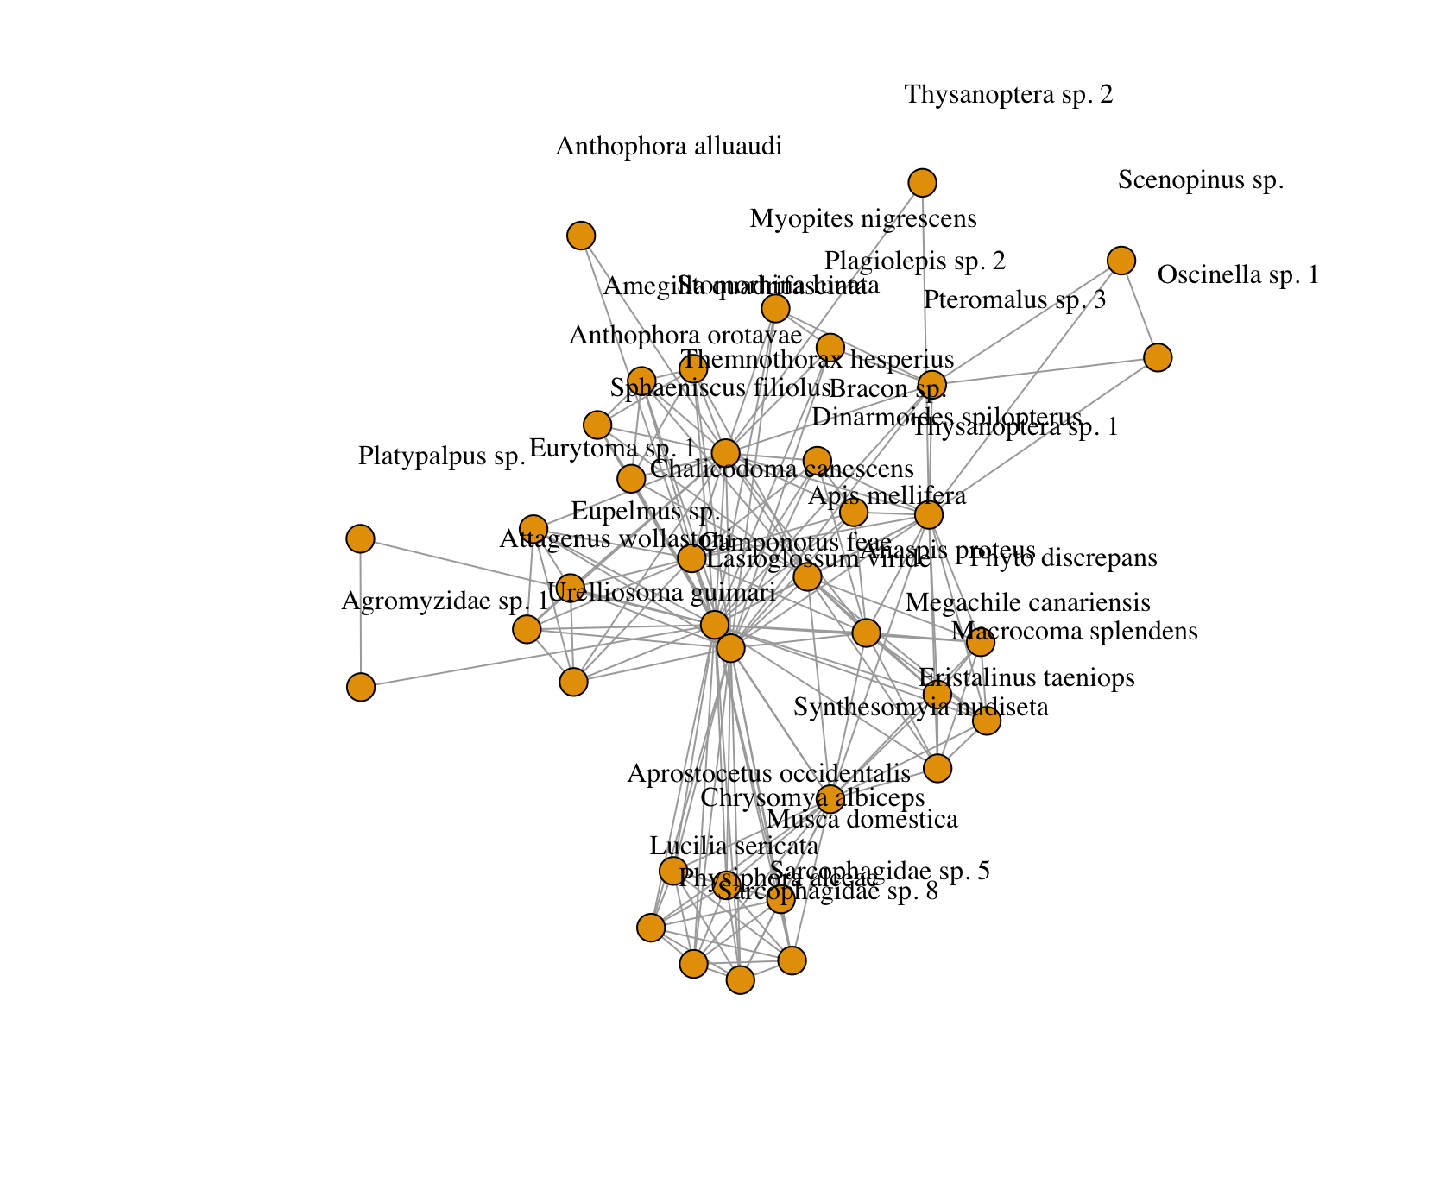

NetWS8: Site8_TenerifeSouth2

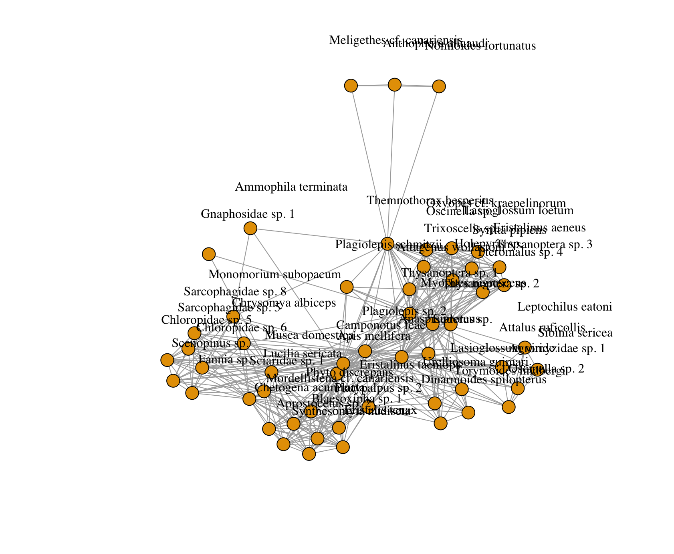

NetWS9: Site9_TenerifeTeno1

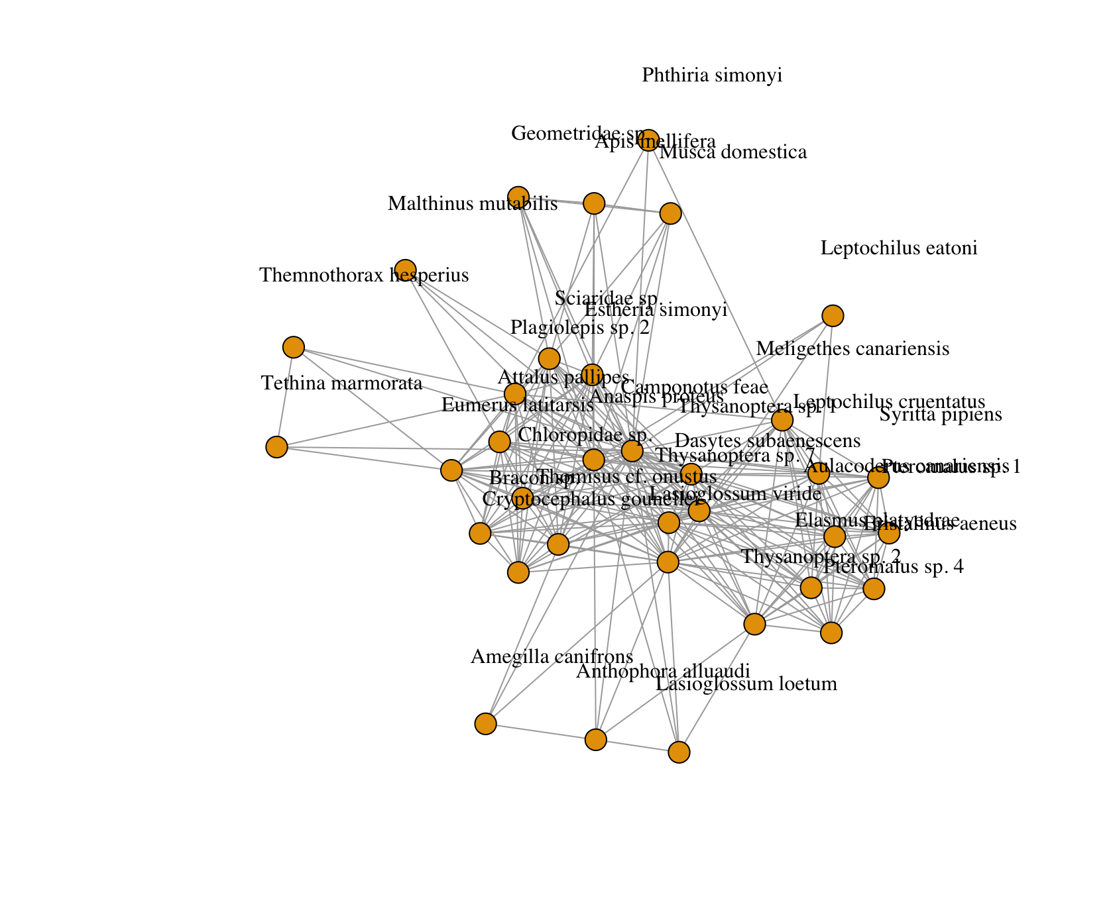

NetWS10: Site10_TenerifeTeno2

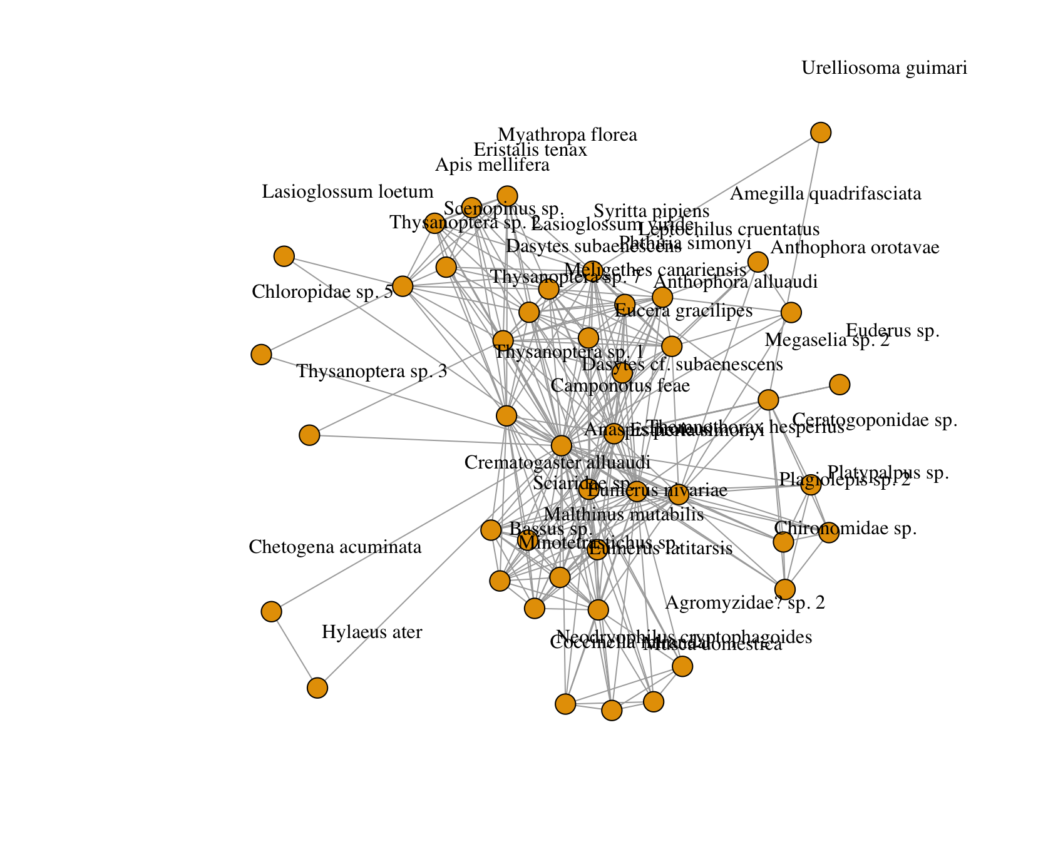

NetWS11: Site11_Gomera1

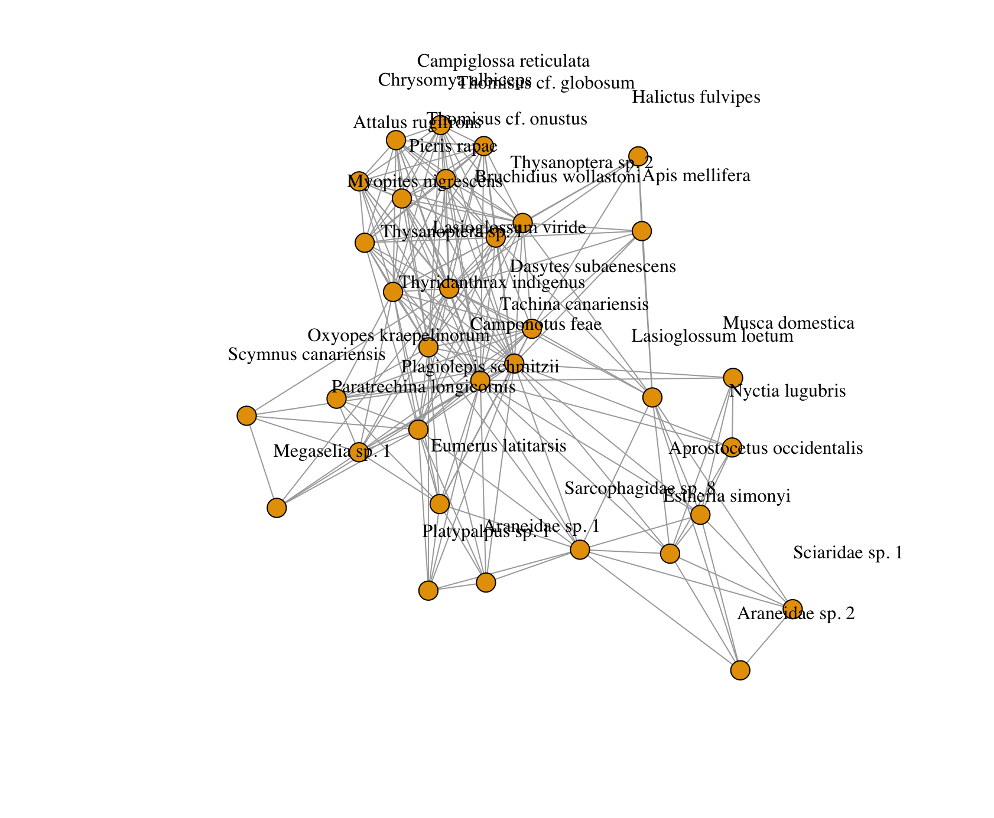

NetWS12: Site12_Gomera2

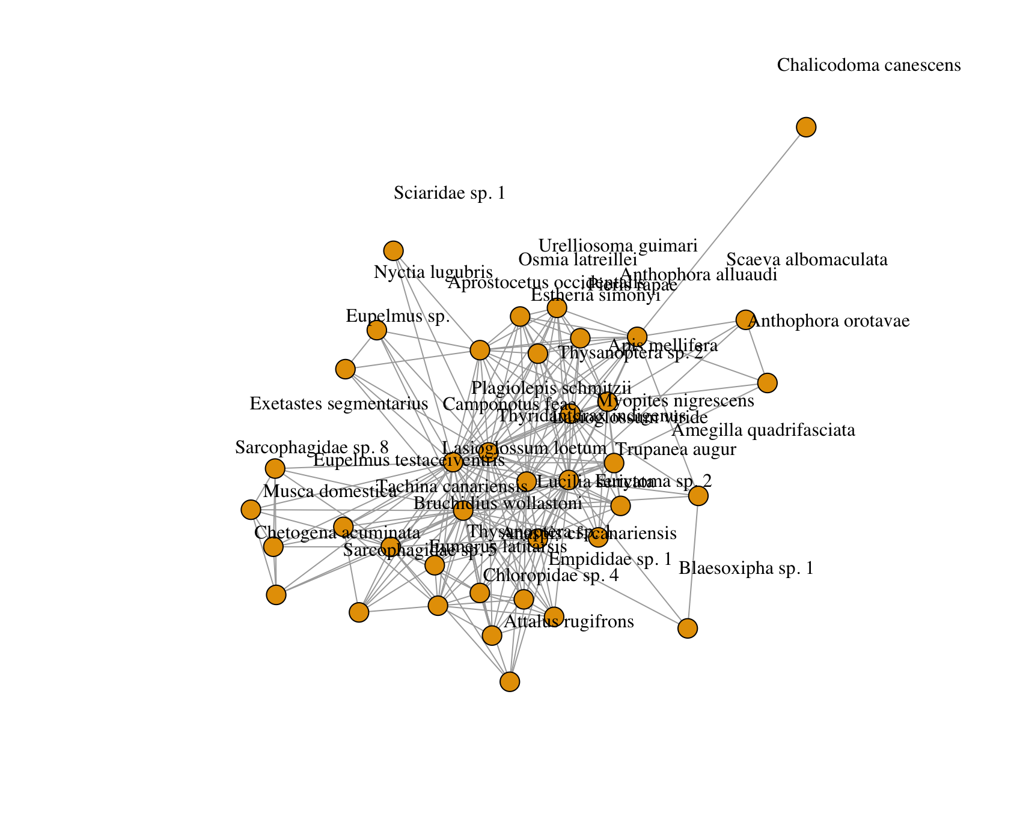

NetWS13: Site13_Hierro1

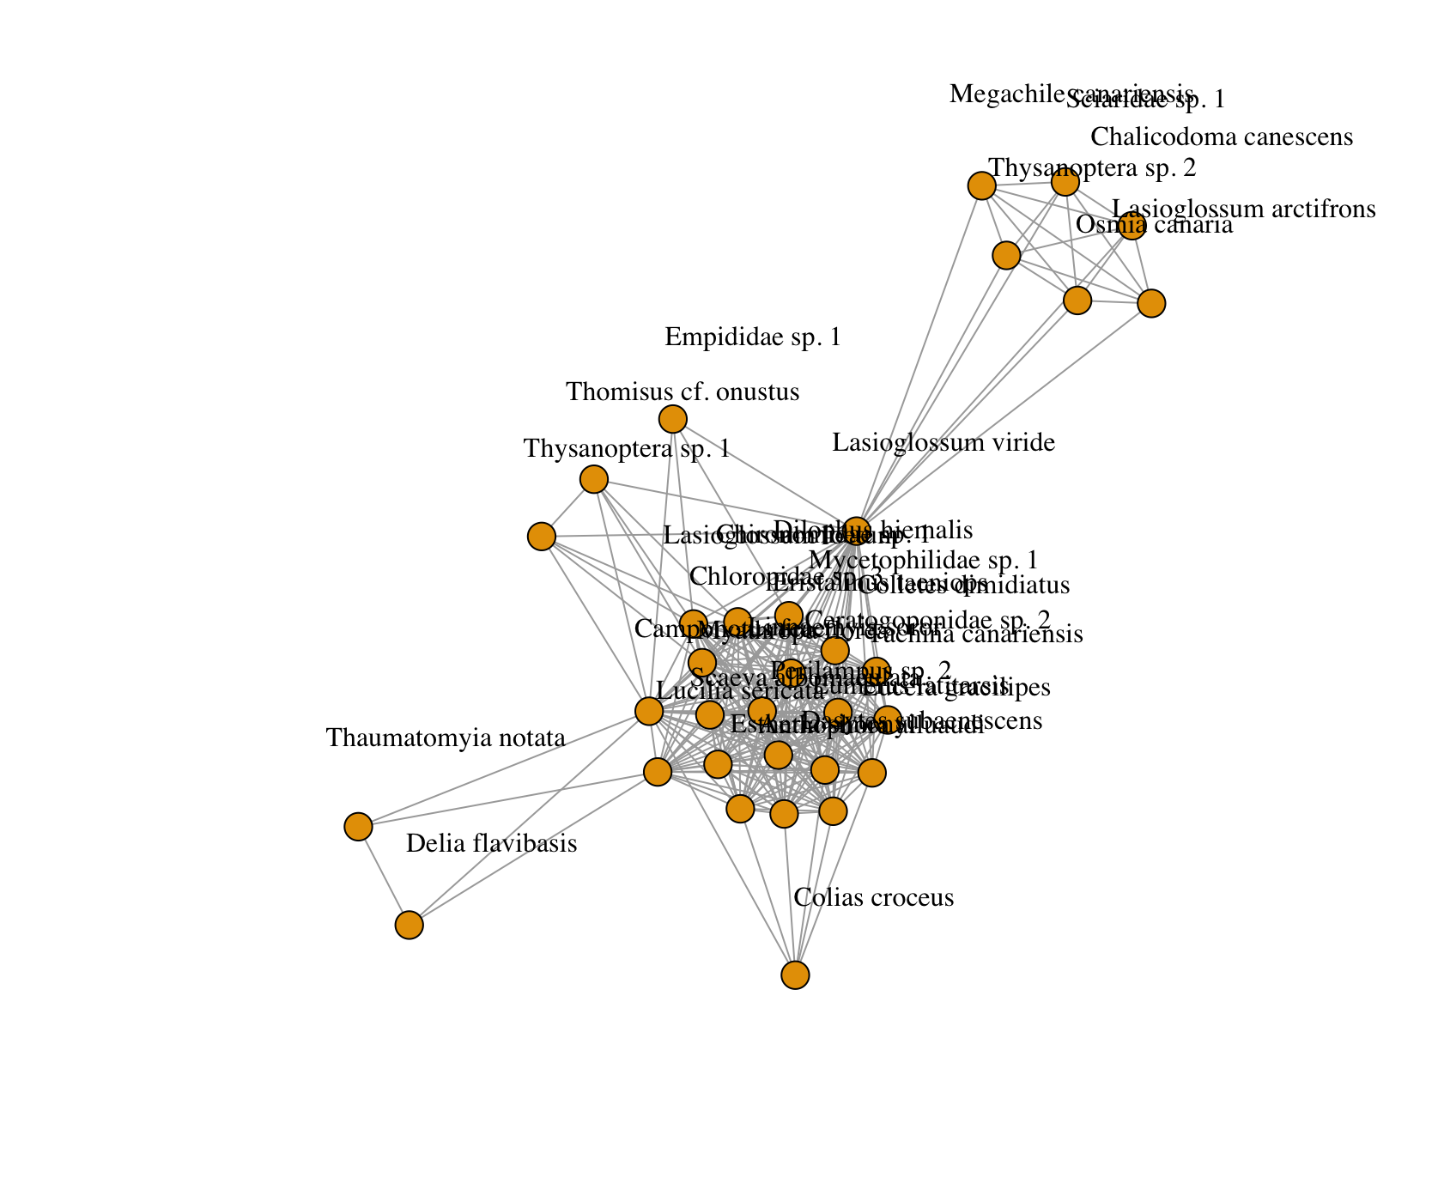

NetWS14: Site14_Hierro2

